Usage guide

Script creation

Each lua script for GameGuru has two main functions, Init and Main.
To mark the beginning of a function on the graph, special nodes are used.

Init
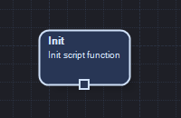
Pic. 1 - Init start node.
The Init function is triggered once when the script is launched, before the first execution of the Main function. May be empty.

Main
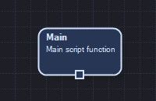
Pic. 2 - Main start node.
The Main function represents the main body of the script, it is executed continuously during the game, often depending on the hardware capabilities.

To add a new function for execution, drag it from the menu on the left to the graph, then add a connector by right-clicking on the graph and selecting the "Add connector" item in the menu.
Attach the connector with the arrow end to the top port of the added function node, and the circle end to the bottom port of the function start node or the previous function node.
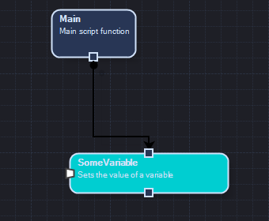
Pic. 3 - Location of the function on the graph.

To build the script into a file, select Build -> Build all from the menu, then specify the location of the file and click save.

Creating functions

To create a new function, you need to create its graph. To do this, select the Functions -> New function graph menu item. You can rename the function you have created by selecting the start node of the function on the graph, then right-clicking and selecting the "Edit" item from the menu.
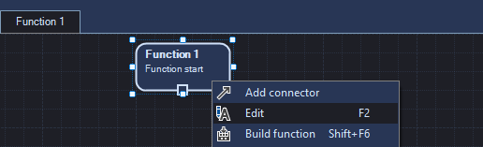
Pic. 4 - Renaming a function.

All the functions you have created can be found in the "Project functions" item in the menu on the left side of the screen.

You can add return and receive values ​​to your function. To do this, open the "Function components" tab in the menu on the left side of the screen, then drag the node you need to the function graph and connect in accordance with the ports on them.

Pic. 5 - Function components in the left menu of the program.

Argument - The value to get.
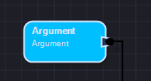
Pic. 6 - Argument Node.

Return - The return value.
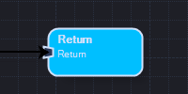
Pic. 7 - Retern Node.

You can rename the nodes of the received and returned values ​​for your convenience by selecting them on the graph, right-clicking and choosing the "Edit" item from the menu.
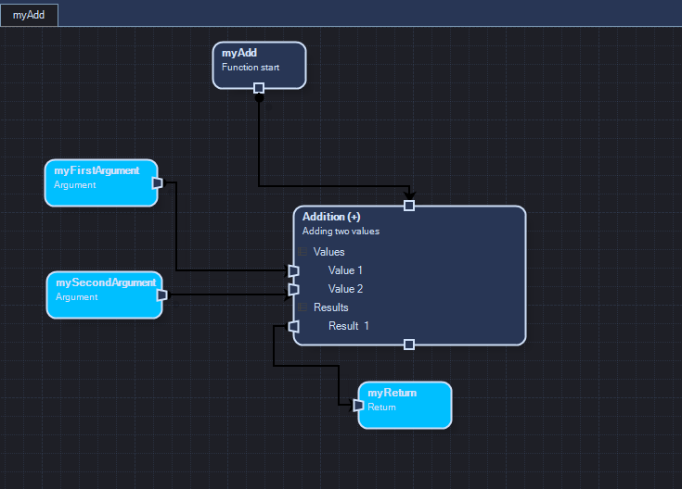
Pic. 8 - Graph of a function that returns the sum of the values obtained through the arguments.

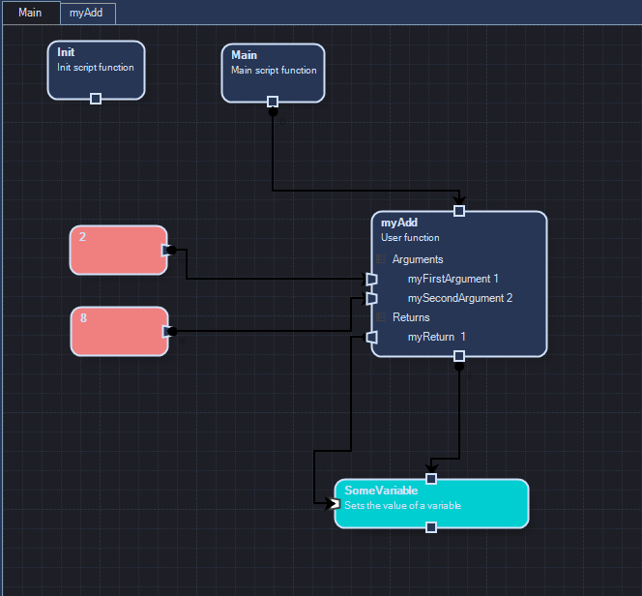
Pic. 9 - Using a user function in the Main function.

Using conditional functions

The script constructor has several functions with conditions that differ slightly in their operation from other functions.

If
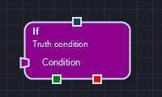
Pic. 10 - Condition function node.
The condition function allows you to execute (or not execute) instructions, depending on the received value of the truth in a logical format (true / false).
On the left port labeled "Condition", the value of the truth is fed. The green bottom port leads to instructions that will be executed if the value passed to the "Condition" port is true. The red bottom port leads to instructions that will be executed after the condition function.

While
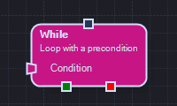
Pic. 11 - Precondition loop function node.
The precondition loop function allows you to repeat any instructions as long as the value passed to it in the logical format (true / false) is true.
On the left port labeled "Condition", the value of the truth is fed. The green bottom port leads to instructions that will be executed as long as the value passed to the "Condition" port is true. The red bottom port leads to instructions that will be executed after the preconditioned loop function.

The script constructor has condition functions for which the value of the truth is predefined (for example: "Player inside the trigger" ). These functions work in the same way as the normal condition function, but do not require a truth value.

